JagTrack

For Load Balancing

Version 1.0

Revision History
Date | Version | Description | Author
12/Mar/12 | 1.0 |  | Xingyu Wang
29/Mar/12 | 1.0 |  | He Zhang

Table of Contents
1. Introduction 4
1.1 Purpose 4
1.2 Scope 4
1.3 Definitions, Acronyms, and Abbreviations 4
1.4 References 4
1.5 Overview 4
2. Overall Description 4
2.1 Use-Case Model Survey 4
2.2 Assumptions and Dependencies 5
3. Specific Requirements 5
3.1 Use-Case Reports 5
3.2 Supplementary Requirements 6
4. Supporting Information 6

Introduction

Purpose
One of the major features of the JagTrack application is load balancing. The purpose of this SRS is (1) to fully describe its external behavior: calculate how many riders are currently on the bus; (2) to describe its nonfunctional requirements, including performance and dependability; and (3) to describe its technology constraints.

Scope
The JagTrack application performs two major features: Boarding JagTran and load balancing. This SRS is associated with the use-case model Bus Load.

Definitions, Acronyms, and Abbreviations
See the Glossary.

References
Glossary
Supplementary Specification

Overview
The rest of this document contains an overall description of the general factors that affect the product and its requirements, all software requirements which are detailed enough for designers and testers, and other supporting information.

Overall Description

Use-Case Model Survey
This section provides an overview of the use-case model Bus Load. The actors involved in this use-case model are the user, rider and sensor.
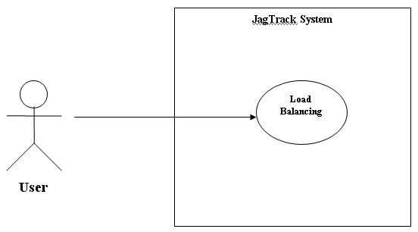
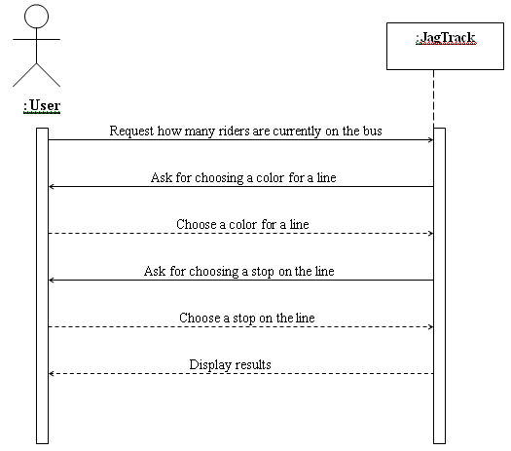

Assumptions and Dependencies
Assume user’s cell phone can get access to the Internet.
Assume the sensors work correctly and efficiently.
Assume the system can read data from the database efficiently.
Assume the system can be easy to update and maintain.

Specific Requirements

Use-Case Reports
Functional requirement: The system is able to figure out how many riders are currently on the bus.
Nonfunctional requirement 1: The system must be made available to user for download.
Nonfunctional requirement 2: Users must have necessary hardware to download software.
Reliability: If the user has operated by mistake in the system, the system will respond the user and prompt operate again.
Performance: After the user has chosen both line color and stop, the system should take no longer than 5 seconds to display the result.
Dependability: Out of 1000 users’ requests, at least 999 should be responded correctly and efficiently.
Technology and tool: Database, sensors, and GPS work in the way they are expected.
Design constraints: Java and C# is very useful, recommend use incremental process and recommend use Netbeans IDE 6.9.1.

Supplementary Requirements
See the document named Supplementary Specification.

Supporting Information
Table of Contents

